AI-Based train Accident Prediction Project ID – 25 -26J -208

Project Proposal Report
Vithanachchi N.Y- IT22285560

Bachelor of Science (Hons) Degree in Information Technology Specializing in
Information Technology

Department of Information Technology
Faculty of Computing

Sri Lanka Institute of Information Technology Sri Lanka (SLIIT)

January 2025

ABSTRACT
Railway accidents due to hidden track damage are a compelling problem, particularly in the Third World where conventional inspection techniques are still prevalent. It is an invitation to have an affordable, real-time railway track monitoring system integrating vibration (SW-420) and sound sensors with an Arduino UNO controller. It continuously monitors vibration and acoustic signatures, checks anomalies in real time, and provides real-time notifications to train drivers and control centers through GSM communication. Unlike the conventional manual checking technique, the method facilitates early detection of cracks, looseness of joints, or misalignment, preventing derailments and collisions. The proposed system is scalable, economical, and suitable for use in both urban and rural setups. A prototype will be produced, tested on simulated crack conditions, and evaluated on detection accuracy, false alarm rate, response time, and cost-effectiveness. This method shows how embedded systems, IoT integration, and real-time data analysis can significantly enhance railway safety and serve as the basis for predictive accident prevention systems in resource-limited infrastructures.

DECLARATION

I declare that this is my own work, and this proposal does not incorporate without acknowledgement any material previously submitted for a degree or diploma in any other university or Institute of higher learning and to the best of our knowledge and belief it does not contain any material previously publish or written by another person expect where the acknowledgement is made in the text.

Name | Student ID | Signature
Vithanachchi N.Y | IT22285560

The supervisor/s should certify the proposal report with the following declaration.
The above candidates are carrying out research for the undergraduate Dissertation under my supervision.

………………………………. ……………..………
Signature of the Supervisor Date
Ms. Lochana Rajamanthri

………………………………. …………………...…
Signature of the Co-Supervisor Date

Table of Contents
ABSTRACT 3
DECLARATION 4
LIST OF ABBREVIATIONS 7
INTRODUCTION 8
  - Background and Literature survey 8
  - Background and Literature survey 8
  - Research Gap G
  - Research Problem 10
OBJECTIVES 11
  - Main Objectives 11
  - Specific Objectives 11
METHODOLOGY 13
Complete System Architecture 13
  - User Interface (UI) Layer 13
  - Controller Layer 14
Backend Services and Database Layer 14
System Diagram 15
Functional Requirements 2
Non-Functional Requirements 3
Technology Selection 3
Gant Chart 4
CONCLUSION C
BUDGET AND BUDGET JUSTIFICATION C
COMMERCIALIZATION 7
References 8
APPENDICES 8

LIST OF ABBREVIATIONS

Key Words | Meaning
GCP | Google Cloud Platform
DB | Database
UI | User Interface
API | Application Programming Interface
Table 1 List of Abbreviations

INTRODUCTION

Background and Literature survey
Railway transport is the most widespread mode of transport globally, moving millions of people and products daily. Despite being the most frequent mode of transport, railway transport accidents caused by track failures such as cracks, rail breaks, and loose joints continue to threaten passenger safety and economic stability more than anything else. It has been proven through research that derailments due to undetected track damage are some of the most frequent reasons for railway accidents in developing countries, where means of inspection are still predominantly manual, time-consuming, and ineffective in real-time monitoring. In Sri Lanka, for example, safety inspections in the railways are typically made by trackmen inspecting on foot, which is prone to human error and cannot detect underlying or sudden cracks.
Emerging technologies in Internet of Things (IoT), embedded systems, and low-cost sensors have provided opportunities for the implementation of automated monitoring systems. Vibration-based fault detection has also been identified as a viable option since track defects leave specific signatures on vibration when passed over by trains. The SW-420 vibration sensor has been used heavily in research prototypes to detect unusual vibrations that indicate misalignment or cracking of tracks. Similarly, acoustic sensors (microphones) are also capable of identifying known patterns of sound such as rail cracks or loose bolts. Ambient conditions such as noise from the environment may be problematic, so calibration and filtering are necessary.
Certain research indicates the application of sensors along with microcontrollers like Arduino UNO for processing in the field. For instance, Karuppusamy et al. (2025) proposed an IoT-based rail monitoring system through vibration and ultrasonic sensors to detect cracks and send alerts using GSM modules. In the same line, SureshKumar et al. (2022) demonstrated the effectiveness of vibration sensors in detecting incipient damage on tracks. These studies validate the usability of low-cost embedded systems in real-time, continuous monitoring but also emphasize the need to improve detection accuracy and reduce false alarms.
While computer vision and camera-based systems using AI-based solutions (e.g., YOLO, Faster R-CNN) have been developed in advanced systems, these systems require a lot of computational power, internet connectivity, and expensive hardware, hence cannot be adopted for railway systems with limited resources. A sensor-based solution based on vibration and sound sensors, supplemented by Arduino for local processing and GSM modules for real-time alerts, is an economical, scalable, and field-deployable solution.
Literature thus poses the potential of fusing vibration and acoustic sensing with inbuilt IoT devices to fill the current research gap: establishing a deployable, low-cost, real-time track damage detection system with instant alerts to the train operators and control centers for enhanced railway safety.

Research Gap

Though there are immense developments in safety features and surveillance technologies for railways, there are some major gaps. Many nations still utilize conventional inspection practices in their countries, including Sri Lanka; however, such conventional procedures are lengthy, manual, and not efficient for real-time fault detection in tracks. Although there are some recent works investigating sophisticated solutions like computer vision, deep learning, and IoT-oriented frameworks for detecting cracks, there is a need for such sophisticated solutions for high computational needs or extensive training samples or expensive sensor installations. Such conditions make such solutions less practical for developing or resource-limited railway infrastructures.

Literature on acoustic and vibration fault detection holds great promise in picking up structural anomalies but most current systems are geared towards controlled environments, few fault types, or are not integrated with real-time warning mechanisms. Most proposed designs also highlight accuracy in a lab setting but are wanting in dealing with external issues such as noise, ballast interference, or animal-stirred vibrations. There is also minimal research integrating both vibration and acoustic sensors into an affordable, embedded device for real-time detection on location.

Therefore, the current body of research highlights a gap in affordable, real-time, and field-deployable railway track monitoring systems that can operate under practical conditions with minimal infrastructure. Specifically, there is a need for a solution that leverages simple, low-cost sensors (such as vibration and acoustic modules) integrated with microcontrollers and GSM communication to provide immediate alerts to railway operators. Addressing this gap will enhance accident prevention capabilities, particularly in developing regions where sophisticated monitoring technologies are not economically viable.

1.3 Research Problem
Research Problem Statement
Undetected track fault sources remain a severe safety and economic threat worldwide. Manual inspection and routine maintenance still remain a prevalent practice for track surveillance for railways in Sri Lanka as well as in other developing countries, which is labor-intensive, cumbersome, and incapable of determining real-time faults. Computer vision- and deep learning-advanced solutions based on IoT are available but require high computational powers, multi-source datasets, and expensive sensor installations in rendering them infeasible for resource-poor infrastructures such as railways. Vibration- and acoustic signal-based approaches in the past are promising but are either limited primarily in a lab setting environment with few fault classes or lack real-time communication or alarm features. Consequently, a serious need remains for low-cost, practical, and scalable apparatuses for real-time detection of track damage to railways.

OBJECTIVES

  - Main Objectives

The main objective of the present research would be to design and develop a real-time on-line track damage detection and alarming system comprising of the integration of vibration and sound sensor with Arduino based data logger and GSM module communication system. This system aims to give preliminary warnings on cracks that can be in a track, defects in the structure or excess movement of the vehicle, which would prevent possible train accidents and preserve human life, animal life, and property.

The aim, in this case, is low cost, scalability, and operation in real-time, so it is appropriate to install the solution in urban and rural railroad networks where the level of sophisticated monitoring infrastructure is not so high.

2.2 Specific Objectives

To deploy vibration and sound sensors on railway tracks for continuous monitoring.

W-420 lowering sensors and audition detectors will be positioned along the rail systems to record in real time vibration as well as acoustic signals that inform about occurrence of cracks between rails, loose joints or any other structural abnormalities.

To acquire and preprocess vibration and sound data using an Arduino UNO.

The Arduino UNO will read continuous values of the sensors, sieve out the ambient noise, and translate the raw data into a form that would be agreeable to processing and fault identification.

To detect and classify railway track anomalies using vibration and sound patterns.

Variations in the collected signals will be analyzed through threshold-based methods or FFT methods so that anomalies can be classified as minor, moderate, or severe and thereby respond in time.

To integrate a GSM-based alert system for immediate fault notification.

A GSM module will initiate real time SMS alerts to the train drivers and the control room operators regarding the location and level of detected visible faults, thus allowing quick decision making and avert accidents.

To develop and test a working prototype for performance evaluation.

A prototype will be designed, built, and tested under controlled conditions (i.e. minor cracks, major cracks) to determine reliability in terms of true detection, the false alarm rates and response time.

To evaluate the scalability and cost-effectiveness of the proposed system.

The system will be evaluated on the possibility of a large-scale deployment in terms of cost of installing the system, the amount of maintenance, energy-efficiency, and compatibility with existing railway safety facilities.

METHODOLOGY
Complete System Architecture

The railway track damage detection system consists of three primary layers designed to ensure continuous monitoring, efficient processing, and immediate response:

- Data Acquisition Layer: This layer is tasked with the physical sensing of train motion-based vibration and sound signals on the rails.
- Controller and Processing Layer- This layer transmits the analysis to a processing module which classifies the faults with the help of microcontroller-based processing and algorithms.
- Communication / Alert Layer- Notifies the train drivers and railway authorities in the event of any anomaly detected through GSM-based communication.
The layered design has the advantage of increasing costs, scalability, reliability and affording it to cover long sections of the railway with a small maintenance.

  - Sensor & Data Acquisition Layer
    - Hardware Components:
      - A vibration measurement through a W-420 vibration sensor that will detect vibrations in the track.
      - Microphone/ acoustic sensor to listen to unusual sounds due to cracks or loose joints and/or broken fasteners.
    - Sensor Placement Strategy:
      - Sensors installed at regular intervals (e.g. at 500 m to 1 km spacing, depending on the sensitivity desired).
      - Enclosures guard against weather and dust and physical impact on sensors.
    - Data Capture:
      - Sensors generate analog signals that are proportional to the level of vibration or the amplitude of sound.
      - These are then sent out to the Arduino UNO analog-digital converter (ADC) where it is digitized.
    - Noise Reduction & Preprocessing:
      - Use low-pass filter circuits to filter the high-frequency dynamic of wind, rain, or small vibrations.
      - Use moving average filtering or Kalman filter to stabilize the signal.
      - Baseline calibration carried out during installation to categorize normal vibrations levels.

  - Controller & Processing Layer

    - Data Handling:
      - The central controller is Arduino UNO.
      - Continuously gets digitized data of sensors with a given sampling rate (e.g., 1-2 kHz).
    - Fault Detection Algorithm:
      - Step 1: Baseline Establishment: Safe normal vibration and sound levels are measured.
      - Step 2: Threshold Detection: Compare real time sensor reading to preset thresholds.
Subordinate divergence → Such is denoted by maintenance signals.
Notable spikes → Deemed the possible crack or damage.
      - Step 3 (Future Scope): FFT or ML: FFT looks at the frequency components and determines a particular pattern brought about by the cracks.
False positives can be minimized later as the SVM and Random Forest classifiers can be trained.

    - Classification:
      - Three fault levels:
- Normal (no action)
- Warning (maintenance check required)
- Critical (immediate train stop alert)
    - Data Logging:
      - An SD card module or onboard memory can be used to store historical data for further analysis.

  - Communication & Alert Layer
- GSM Module Integration:
    - GSM module (e.g., SIM800L) to Arduino.
    - Transmits SMS notices to control centers and the engines of trains at once whenever defects are identified.
- Alert Details Include:
    - Fault type and severity level.
    - GPS coordinates the detected anomaly.
    - Timestamp of detection.

- Optional IOT Integration (Future Scope):
    - Data can be uploaded to a cloud dashboard via GSM/4G for centralized monitoring.
    - Web interface for railway authorities to track historical and real-time fault locations

- Backend Services & Data Storage (Optional for Advanced Implementation)
- Offline logging in SD card.
- Scalable, cloud-based monitoring (e.g. Firebase, AWS IOT).
- All I/ML models are retrained periodically on historical data in order to improve detection accuracy.

  - System Testing & Validation

- Prototype Testing Setup:
- Install sensors on prototype or a model railway or a model on a piece of track under control.
- Introduce simulated faults that correspond to artificial cracks, loose bolts or missing fasteners.
- Performance Metrics:
- Accuracy (%) - is the ratio between the correctly detected events, and the total amount of events.
- False Alarm Rate: The number of misleading alerts under normal use.
- Response Time: Distance between time of detection to alert dispatch (rate of less than 5 seconds).
- Durability Testing: Test how the system withstands in different weather and load conditions.

  - Scalability and Maintenance

- Scalability Plan:
- It is possible to deploy modular sensor nodes at intervals and connect to a centrally located monitoring facility.
- The nodes use solar energy and low-power microcontrollers in order to cover distant areas.
- Maintenance:
- Very little hardware maintenance (GPS sensor recalibration once a year).
- Applies firmware upgrade in case there is need over the GSM network

  - Ethical, Safety, and Cost Considerations

- Ethical:
- Data privacy ensured, no human and wildlife interference through the system.
- Safety:
- System stops only in serious situations to prevent unwanted, unnecessary delays.
- Cost:
- Inexpensive, commercial-grade sensors and microcomputers are utilized.

System Diagram
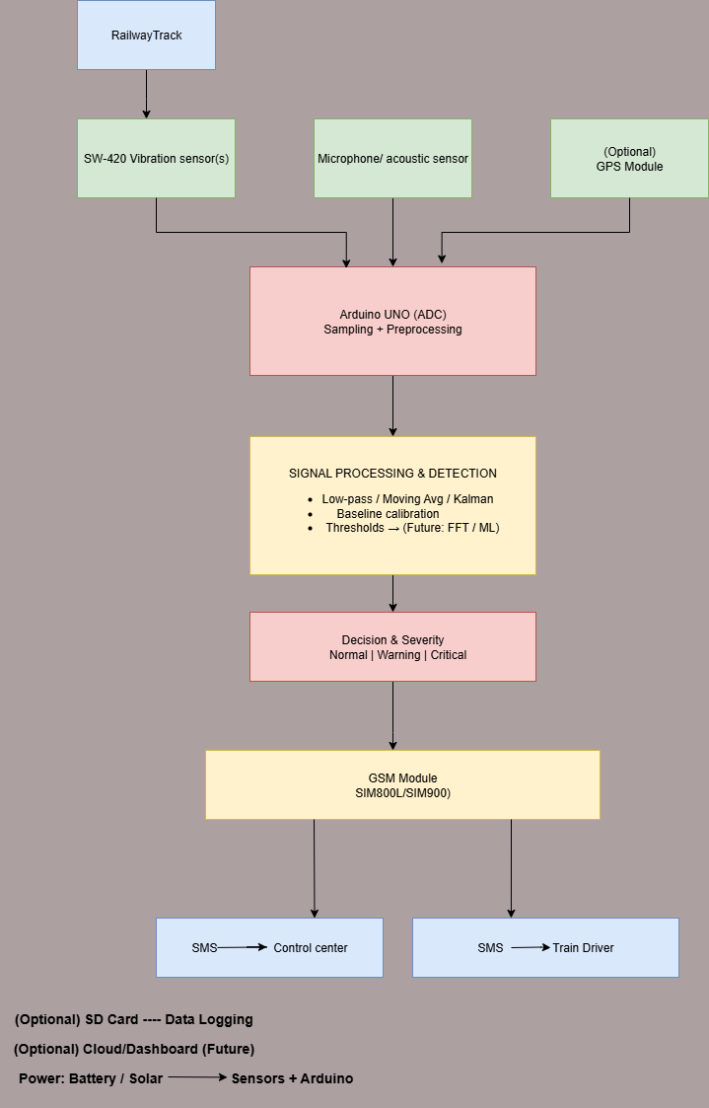

Figure 1 System Diagram

Functional Requirements

    - Railway Track Condition Monitoring
  - The system should keep an eye out for unusual sound and vibration signals on railroad tracks.

  - The SW-420 vibration sensor will be used by the system to identify variations in vibration patterns.

  - The system will record any acoustic irregularities that might point to fractures or cracks.

    - Data Processing & Fault Detection
- The Arduino UNO will process data from sensors in real time.
- To detect possible track damage, the system will compare gathered data to predetermined thresholds.
- By differentiating between real fault indicators and typical operating vibrations, the system will reduce false positives.

    - Alert Generation & Communication
- The system will produce an alert message when a potential malfunction is detected
- The railway control center and train driver will receive an SMS alert from the GSM module.
- If GPS or predefined sections are integrated, the alert should contain pertinent information like the track section ID and location.

    - System Reliability & Responsiveness
- Within a few seconds of an anomaly occurring, the system must identify it and report it.
- Even when there are environmental disruptions like noise or slight vibrations, the system will continue to monitor.
- The system must guarantee consistent performance with little downtime.

    - Scalability & Deployment
- The system should be affordable to implement on several railroad track segments.
- Additional sensors, such as an accelerometer for sophisticated vibration detection or a GPS module for location tracking, can be integrated with the system.
- Data logging will be supported by the system for analysis and performance evaluation in the future.

Non-Functional Requirements

- Performance
- Within two to five seconds of an abnormal vibration or sound pattern occurring, the system must identify and categorize it.
- Within ten seconds of detection, the GSM module must notify the appropriate staff.
- In real-time monitoring, the system must run continuously with little latency.

- Reliability
- Throughout operation, the system must maintain a minimum of 95% uptime.
- By removing typical train-induced vibrations, the system will reduce false positives and false negatives.
- Typical railway environmental conditions, such as dust, heat, vibration, and moderate humidity, must be tolerated by the system.

- Scalability
- The system must be built to be easily deployed over several railroad track segments.
- Additional sensors (such as accelerometers for in-depth vibration analysis and GPS for location tracking) will be able to be integrated thanks to the architecture.
- For widespread deployment, the system will facilitate growth to a centralized monitoring platform.

- Cost-Effectiveness
- Low-cost, commercially available sensors (such as the SW-420 vibration sensor and simple microphones) will be used in the system.
- For widespread adoption in emerging railway networks, the total setup cost per monitoring unit must continue to be reasonable.

- Maintainability

- Sensors or modules can be easily replaced by the system without requiring significant reconfiguration.
- It will be possible to upgrade the Arduino-based firmware to accommodate better detection algorithms.
- System calibration should be simple and require little technical know-how.

- Usability
- Alerts must be clear, succinct, and simple enough for train drivers and control center employees to understand.
- The system will operate with little assistance from humans.
- Both technical employees (maintenance teams) and non-technical staff (train operators) should find the design easy to use.

- Energy efficiency
- must run on battery/solar for long deployments.

- Data security
- GSM messages can't be spoofed.

- Portability
- device must be compact & weather-proof.

Technology Selection

- Programming Languages
- Programming the Arduino UNO to interface with sound and vibration sensors, process sensor data, and manage GSM communication is done using C and C++.
- Offline data preprocessing, signal analysis (FFT, filtering), and the training/testing of sophisticated detection models in the event that machine learning is later incorporated are all done with Python (Optional – Data Analysis & Model Training).

- Databases
- For offline analysis and retraining of detection algorithms, collected vibration and sound data logs are stored in local storage (SD Card Module, optional).
- Centralized sensor node monitoring, fault alert storage, and integration with a web/mobile dashboard for railway authorities are all possible with the Firebase Realtime Database (Optional – Future Expansion).

- Communication Technologies
- When anomalies are found, the GSM Module (SIM800L/SIM900) immediately notifies control centers and train drivers via SMS.
- An optional GPS module allows for precise location tagging of identified issues, facilitating quicker maintenance response.

- Sensor Technologies
- SW-420 Vibration Sensor – Detects abnormal vibrations, cracks, or breaks in the railway track.
- An extra detection parameter is provided by the microphone/acoustic sensor, which records sound abnormalities such as loose joints and rail crack noise.

- Machine Learning & Signal Processing Frameworks
- During experimental analysis, NumPy and SciPy (Python) are used for digital signal processing (filtering, Fourier transform).
- TensorFlow and Scikit-learn (Optional; Future Expansion): These tools are used to create and evaluate machine learning models for fault classification based on sensor data.

- Development & Deployment Tools
- The Arduino IDE is used to upload code to Arduino UNO, debug it, and program embedded systems.
- Prior to actual deployment, circuit behavior can be simulated using Proteus or Tinker cad (Optional – Simulation).
- MATLAB/Python (Jupyter Notebook: Optional): Used for the analysis and visualization of experimental data during the research stage.

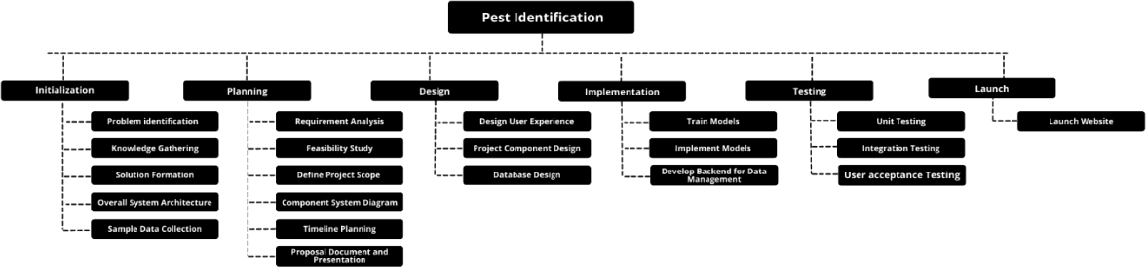
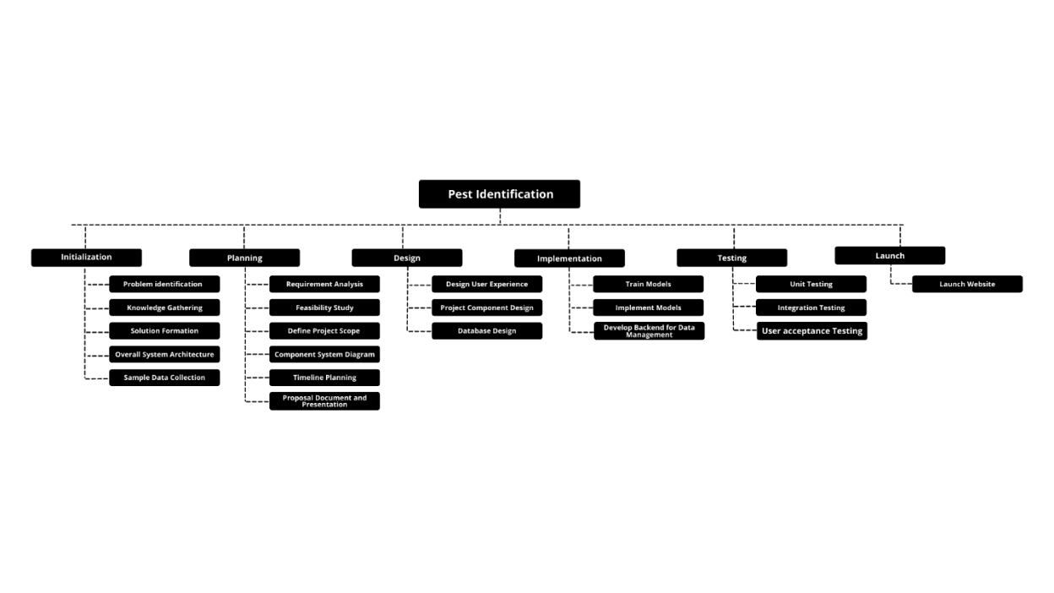
Gantt Chart
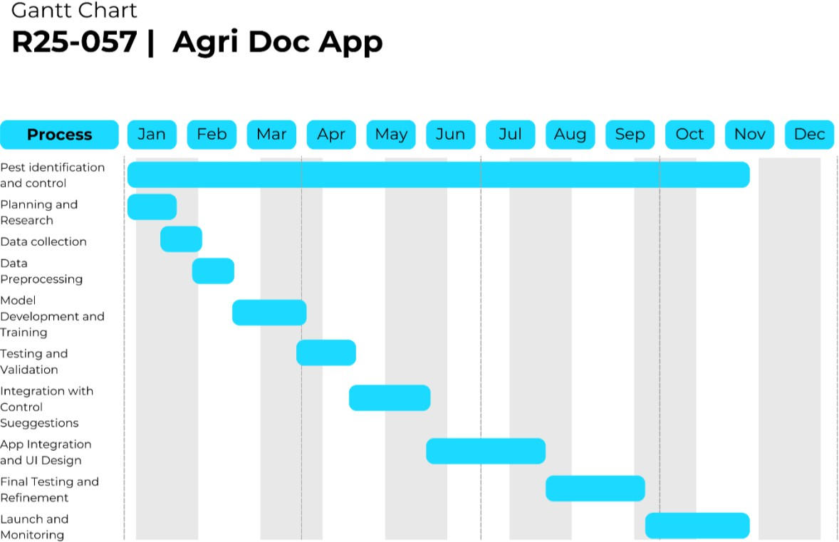
Figure 2 Gantt chart

Work Breakdown Structure

Figure 3 Work Breakdown Structure

CONCLUSION

Railway safety continues to be a problem everywhere, primarily where traditional manual inspection is the norm. Track defects such as cracks, fractures, and loose joints are often not noted until they lead to catastrophic accidents. The proposed solution — a vibration and sound sensor-based real-time train track damage detection system using an Arduino UNO and GSM module — serves to bridge this critical gap by offering a low-cost, deployable, and scalable safety solution.

The system's ability to continuously monitor vibrations and acoustics, process locally, and trigger real-time alerts to train drivers and control centers ensures quick response and pre-emptive action. Compared to computer vision or AI-based technologies with high computational capability and costly infrastructure, the solution is simple, cheap, and adaptable to urban as well as rural railway conditions.

With this prototype, the research demonstrates how embedded systems and IoT integration can significantly enhance real-time monitoring, reduce reliance on manual inspection, and increase the safety performance of railways. Moreover, its ease of maintenance, scalability, and integration with existing railway infrastructure make it an effective solution for large-scale deployment.

BUDGET AND BUDGET JUSTIFICATION

Item | Description | Cost Estimation

Table 2 Budget and Justification

COMMERCIALIZATION

The proposed rail track damage detection system is very commercialized because it is very cheap, simple, and has a very high safety impact. Compared to expensive AI and computer vision-based solutions involving expensive infrastructure, high computational power, and continuous internet connection, the system involves low-cost vibration and noise sensors alongside Arduino and GSM modules, which is a strong candidate for mass deployment in developing countries.

Target Users:
- Sri Lanka Railways and other South Asian rail networks where manual inspection is the sole proven track safety.

- Indian Railways beset by frequent derailments and accidents caused by track defects in rural and remote regions.

- Poor-resource and developing nations where adoption of high-cost AI-based solutions is economically not feasible.

Advantages for Adoption:

- Low-cost deployment:
All monitoring units use commercially off-the-shelf sensors and modules that keep installation costs minimal.

- No internet reliance:
GSM-based SMS notification functionality works even in areas with no connection and in locations far away, ensuring smooth communication.

- Easy deployment and maintenance:
Ultra-low profile allows easy setup at regular intervals on tracks, with minimal technical knowledge needed for maintenance.

Scalability:

- The system can be modularly installed at intervals of 500 m to 1 km, giving total coverage to large sections of railways. For large-scale deployment, the sensor nodes can be linked to a common cloud-based dashboard, from which the authorities can monitor real-time data, historical records, and predictive analytics of multiple sites simultaneously.

Marketability and Socio-Economic Impact:

- This system provides an affordable alternative to costly AI/vision-based accident detection systems, hence being ideal for governments, railway authorities, and private operators. By reducing accidents, preventing derailments, and reducing human and material losses, the system not only enhances public safety but also reduces the economic costs of railway conflicts. Its ability to integrate into future IoT and predictive AI platforms also adds to its market value and long-term sustainability.

References
- M. Abadi et al., "TensorFlow: Large-Scale Machine Learning on Heterogeneous Systems," 2016. [Online]. Available: https://www.tensorflow.org/
- J. Redmon and A. Farhadi, "YOLOv3: An Incremental Improvement," arXiv preprint
arXiv:1804.02767, 2018.
- OpenCV Team, "OpenCV: Open-Source Computer Vision Library," 2023. [Online].
Available: https://opencv.org/
- M. Badrinarayanan, A. Kendall, and R. Cipolla, "SegNet: A Deep Convolutional Encoder- Decoder Architecture for Image Segmentation," IEEE Transactions on Pattern Analysis and Machine Intelligence, vol. 39, no. 12, pp. 2481–2495, Dec. 2017.
- Google LLC, "Firebase: Real-time Database and Cloud Storage," 2023. [Online]. Available: https://firebase.google.com/
- S. Van Rossum, "FastAPI: A Modern, Fast (high-performance), Web Framework for Building APIs," 2023. [Online]. Available: https://fastapi.tiangolo.com/
- S. Ruder, "An Overview of Multi-Task Learning in Deep Neural Networks," arXiv preprint
arXiv:1706.05098, 2017.
- P. Bojanowski, E. Grave, A. Joulin, and T. Mikolov, "Enriching Word Vectors with Subword Information," Transactions of the Association for Computational Linguistics, vol. 5, pp. 135– 146, 2017.
- M. I. Jordan and T. M. Mitchell, "Machine Learning: Trends, Perspectives, and Prospects,"
Science, vol. 349, no. 6245, pp. 255–260, Jul. 2015.
- Amazon Web Services (AWS), "Amazon S3: Scalable Object Storage," 2023. [Online]. Available: https://aws.amazon.com/s3/

APPENDICES
  - Technology Stack
Frontend – Flutter Backend - Phyton
Database – fire base Data base

